**SESHADRI RAO**

**GUDLAVALLERU ENGINEERING COLLEGE**

(An Autonomous Institute with Permanent Affiliation to JNTUK, Kakinada)

Seshadri Rao Knowledge Village, Gudlavalleru

**Sustainable Smart City Assistant using IBM Granite**

1. **Introduction:**

* **PROJECT TITLE:**

**Sustainable Smart City Assistant using IBM Granite**

* **TEAM MEMBERS:**

**Team ID :** LTVIP2025TMID32002

Yarlagadda Asha Sri

Vardhe Kavitha Devi

Vanabathina Saritha

Veerla Hanumath Kumar

**OBJECTIVE:**

To develop an intelligent and interactive **Sustainable Smart City Assistant** that leverages **IBM Granite LLM** and internal machine learning models to provide real-time environmental insights, KPI monitoring, personalized eco-friendly recommendations, and citizen feedback analysis. The system aims to support urban sustainability goals by facilitating data-driven decision-making, promoting eco-awareness, and enhancing citizen engagement through a **Streamlit-based frontend** and a **FastAPI backend**.

1. **PROJECT OVERVIEW:**

* **PURPOSE:**

The Sustainable Smart City Assistant aims to empower city planners, administrators, and citizens with intelligent, real-time insights and guidance to promote eco-friendly urban living. Built using FastAPI, Streamlit, and powered by IBM Granite LLM, this assistant provides a centralized platform to:

* + - * + Monitor city performance metrics.
        + Deliver personalized eco-tips.
        + Summarize lengthy policy documents.
        + Enable natural language interaction.
        + Collect structured citizen feedback.
* **FEATURE:**
  + - * + Smart City KPI Monitoring.
        + AI-Powered Eco Tips.
        + Granite AI Q&A Chat Assistant.
        + Citizen Feedback Form.

1. **ARCHITECTURE**:

**Layer         Technology     Description**

Frontend     - Streamlit      - Interactive UI (chat, forms, dashboards)

Backend       - FastAPI       - REST API endpoints for all services

AI Engine    - IBM Granite LLM - Natural language responses &summarization

Forecasting  - Python ML       - Simple linear regression for predictions

Storage (optional) - SQLite or CSV - Stores feedback, KPI data

1. **SETUP INSTRUCTIONS:**
   * + **Prerequisites:**
       - Python
       - FastAPI
       - Streamlit
       - IBM Watsonx/Granite LLM
       - Requests Libraries
       - Project structure
       - VS Code
     + **INSTALLATION:**
       - Download the project
       - Install Python
       - Create virtual environment
       - Install required python packages
       - Run the back-end server
       - Run the streamlit front-end
2. **FOLDER STRUCTURE:**
   * + **Client:**
       - Contains everything related to the **frontend interface**, built using **Streamlit**.
     + **Server:**
       - Contains the **FastAPI backend**, which powers the app's logic and AI services.
3. **RUNNING THE APPLICATION:**
   * + Back-end:

cd back-end

pip install -r requirements.txt

uvicorn main:app –reload

* + - Front-end:

cd front-end

pip install -r requirements.txt

streamlit run main_dashboard.py

1. **USER INTERFACE:**
2. **FRONT-END:**

* smart_dashboard.py

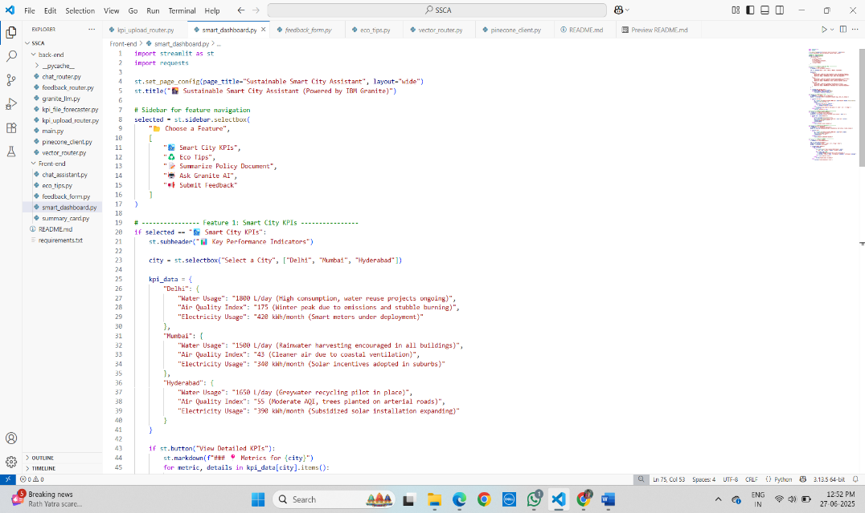

* feedback_form.py

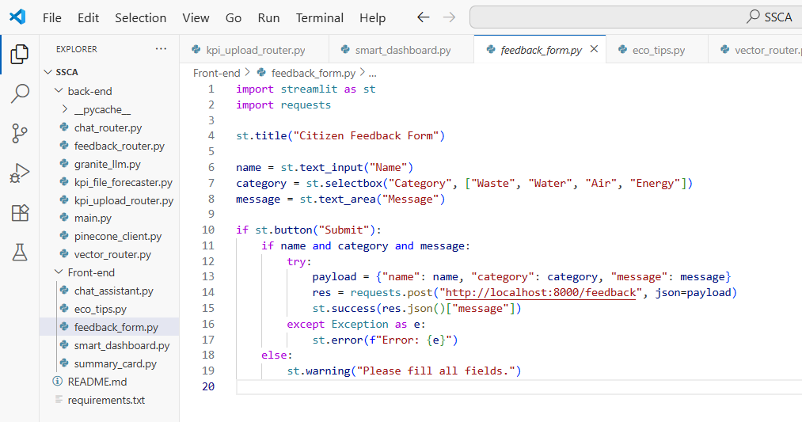

* chat_assistant.py

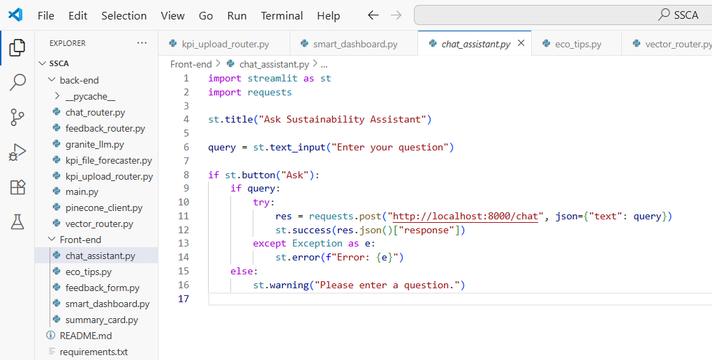

* eco_tips.py

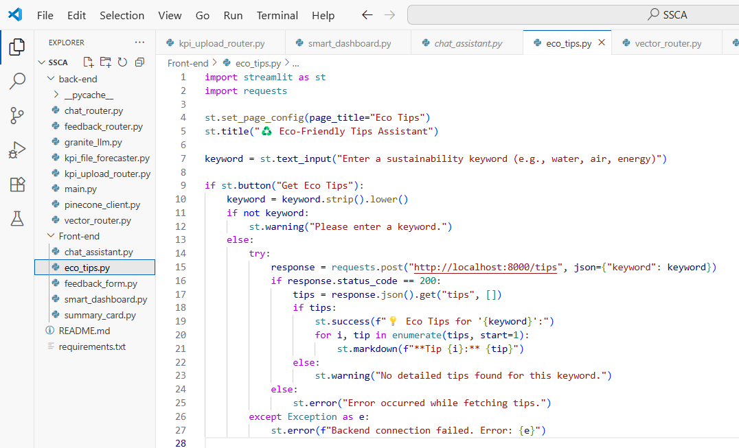

* summary_card.py

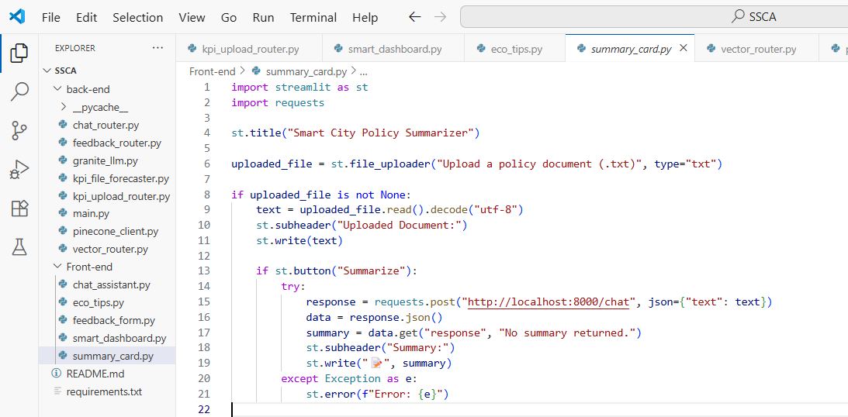

1. BACK-END:

* main.py

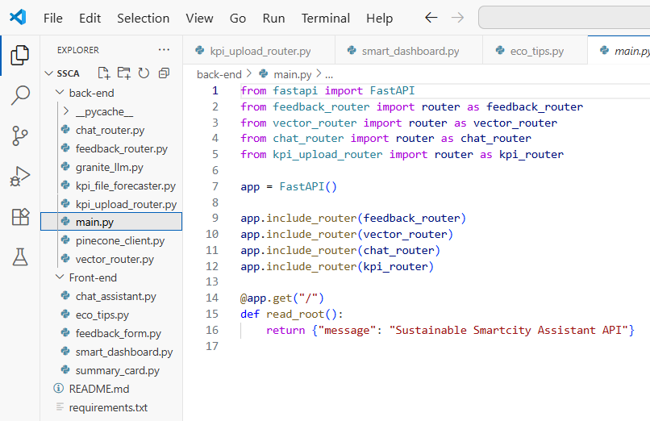

* vector_router.py

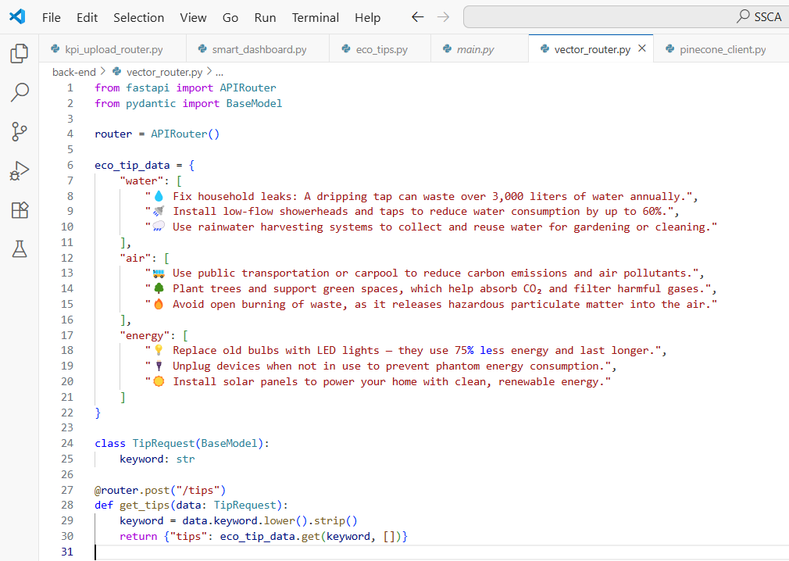

* chat_router.py

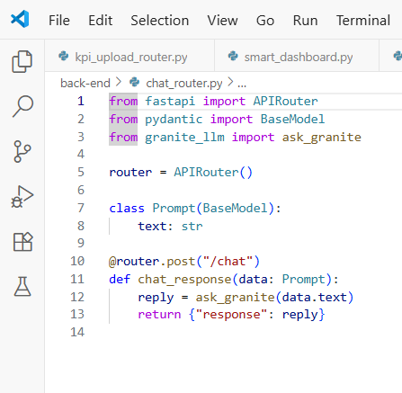

* feedback_router.py

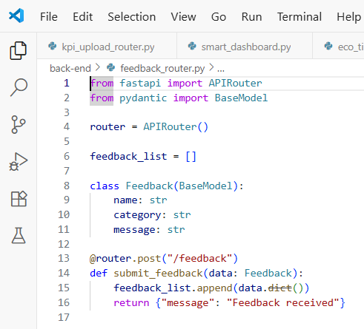

* kpi_upload_router.py

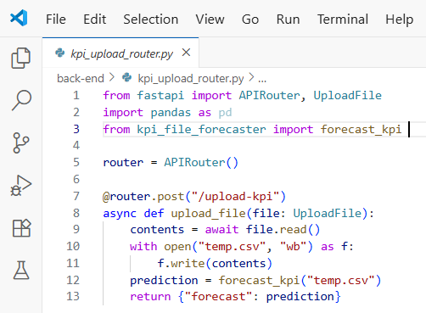

* granite_llm.py

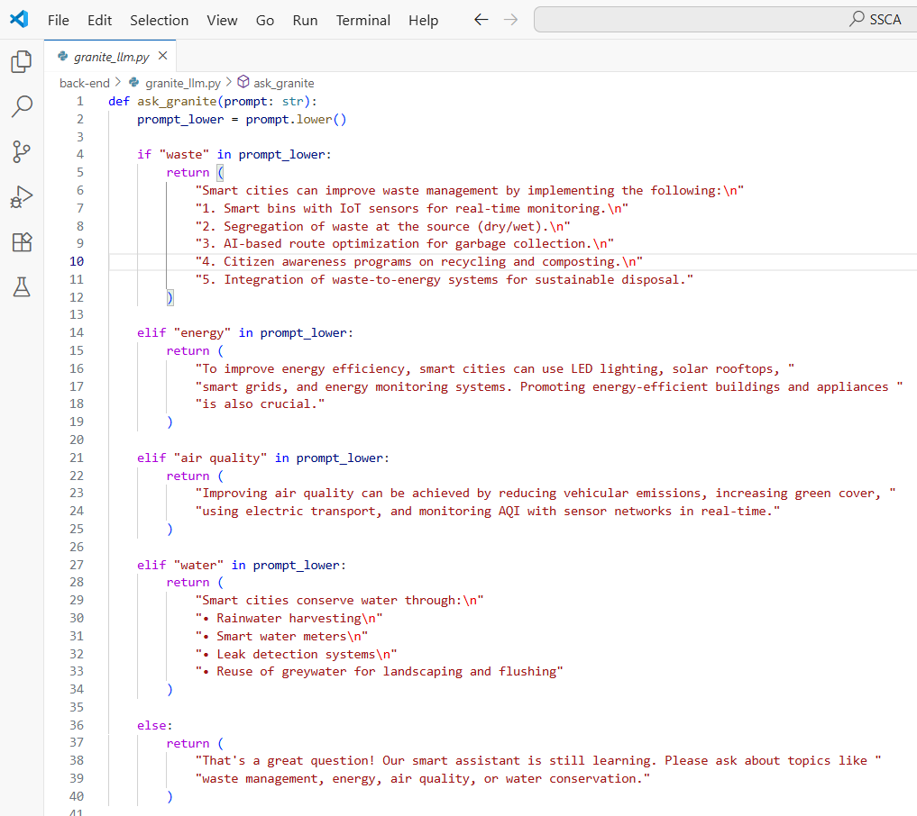

* pinecone_client.py

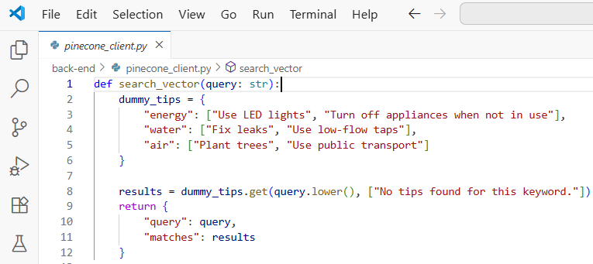

* kpi_file_forecaster.py

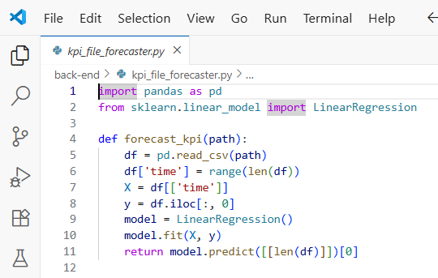

1. requirements.txt

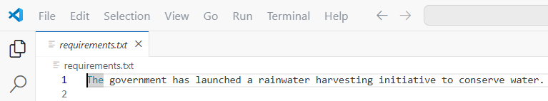

1. README.md

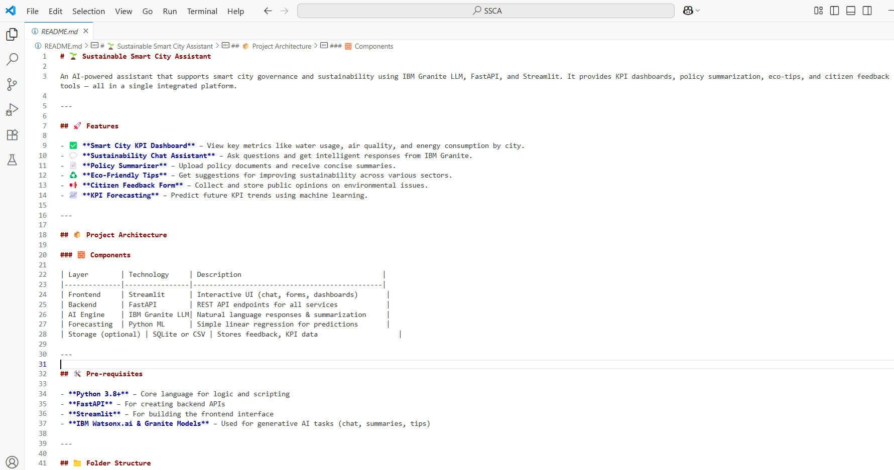

1. **DEMO:**

* Link:

[**https://drive.google.com/file/d/1cREI09d4w6_QSoLkWQJIAivospB61Ss/view?usp=drive_link**](https://drive.google.com/file/d/1cREI09d4w6_QSoLkWQJIAivospB61Ss/view?usp=drive_link)

**CONCLUSION:**

The Sustainable Smart City Assistant is an AI-powered web application designed to promote eco-friendly urban living by integrating real-time KPI monitoring, personalized eco tips, AI-driven policy summarization, and citizen feedback collection into a unified platform. Built using FastAPI, Streamlit, and IBM Granite LLM, it provides intelligent, interactive support for both city administrators and citizens. This project highlights the role of AI in sustainable development and demonstrates how smart technologies can foster data-driven decisions and community engagement for cleaner, greener, and more efficient cities.